Fetal cells remain in moms for years, affecting health
Liz Szabo, USA TODAY11 a.m. EST February 12, 2014

New study in mice shows that fetal cells carried by moms after they give birth may actually provide stem cells to help the body repair some damage.
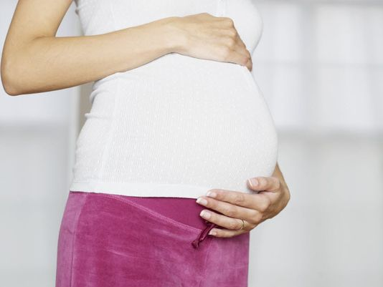
(Photo: Thinkstock.com)

STORY HIGHLIG
Many moms carry photos of their children in their wallets.
Yet mothers may be surprised to learn that they're also carrying some of their children's cells, years or even decades after the end of a pregnancy. And while a baby photo can melt a mother's heart, the cells her child leaves behind in her blood may actually heal it, emerging research suggests.
Doctors have known for years that mothers and babies exchange blood during pregnancy and childbirth, says V.K. Gadi, associate professor at the University of Washington and an associate member at Seattle's Fred Hutchinson Cancer Research Center. Studies now show that fetal cells remain behind, long after pregnancy, in 40% to 70% of women studied. And moms aren't the only ones collecting souvenirs. Kids may also carry cells from their mothers, as well as their twin siblings.
"You live on in them, and they live on in you," says Louise McCullough, director of stroke research at the University of Connecticut Health Center.
Yet the fetal cells left behind in women's bodies are more than mementos.
Preliminary evidence suggests these cells may also come to a mother's rescue when she suffers an injury, such as a stroke, McCullough says.
In a mouse study presented Wednesday at the American Heart Association's International Stroke Conference in San Diego, McCullough and her colleagues found that these fetal cells act something like stem cells – an extremely flexible cell that can give rise to many specific cell types.
She studied fetal cells in mother mice who had suffered strokes.
Like stem cells, the fetal cells homed in on the area of the brain where the stroke occurred. Within 72 hours of the stroke, fetal cells were clustered around the area of the stroke, which was caused when a blood vessel was blocked by a clot, depriving the brain of oxygen, her study found.
But these fetal cells were more than bystanders, McCullough says. They also began dividing and giving rise to the types of cells that line blood vessel walls, as if trying to form new blood vessels to restore blood flow to the injured brain.
What scientists don't yet know, Gadi says, is whether the fetal cells were clustered around the stroke site by coincidence, or if they really were acting like stem cells attempting to regenerate tissue. McCullough presented her research in abstract form. She has not yet published the full paper in a peer-reviewed journal.
But scientists have made similar observations in mice with heart failure. The mice who recovered best were ones in which fetal cells integrated into their heart tissue, says Gadi, who wasn't involved in McCullough's research. In a study in humans, researchers found maternal cells at work in a diabetic child, apparently trying to repair insulin-producing cells, he says.
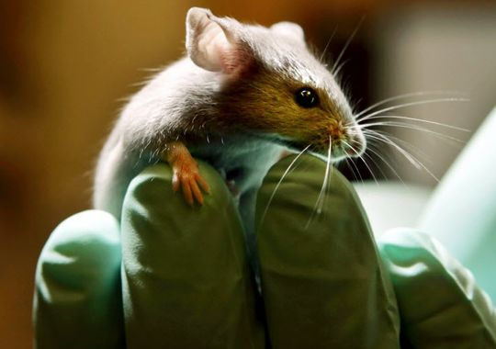
Studies in mice show that mothers may carry cells from their babies years after delivery, and that these cells may aid the mother if she suffers a stroke.(Photo: Robert F. Bukaty)
Fetal cells appear able to change into whatever specific type of cell is needed, McCullough says. So fetal cells in a mother with liver damage could transform into liver cells.
Scientists are studying the role of fetal cells in other diseases, such as cancer, Gadi says. Some research suggests that fetal cells may help to keep watch for malignant cells. Some studies suggest that mothers who fail to maintain fetal cells may be more vulnerable to cancer, he says.
Researchers have many unanswered questions. One of the most central, of course, is whether these fetal cells will lead doctors to develop better treatments for disease, Gadi says.
Yet he notes that family relationships are never simple.
While fetal cells may protect women from some diseases, it's also possible that they cause others, particularly autoimmune conditions, McCullough says. These diseases – which include rheumatoid arthritis, lupus and some thyroid conditions – occur when the body's natural defense, the immune system, begins attacking the body as if it were a foreign invader. Although doctors don't understand what causes these disorders, they do know that they're several times more common in women than men. And they often develop during women's childbearing years.
It's possible that the mixture of blood and cells between mother and child causes immune confusion, prompting a woman's body to begin attacking itself, Gadi says.
"That's the fascinating thing about mom-baby communication," McCullough says. "It kind of never goes away."

